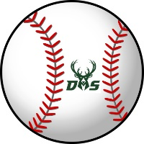

**2023 Deerlake Baseball Tryout Form**

Student Name _______ _____________________Grade Level Date of Birth

Parent Name(s)

Parent Phone #

Parent Email

**Tryout Dates & Times:**

**Tryouts location: Chiles High School**

Wednesday, October 4 @ 5:00-7:00PM @ Chiles H.S.

Thursday, October 5 @ 5:00-7:00PM @ Chiles H.S.

Friday October 6 @ 5:00-7:00 @ Chiles H.S.

**ALL PLAYERS WHO WISH TO TRY OUT MUST MEET THE FOLLOWING CRITERIA:**

* Have proof of a current physical form from a doctor on file in the front office. (A physical is valid for 12 months from the date when it was obtained.)
* Have a current Activities Form on file in the front office (blue form turned into C Period at the beginning of the year).
* Have a minimum 2.0 GPA for the prior nine weeks.
* Return this permission slip to Mr. Burkey by **Oct. 2nd** to participating in tryouts.
* No players will be permitted to tryout unless all criteria above have been met.

Student Signature

I give my child permission to try out for the Deerlake Baseball Team:

Parent Signature Date

If you have questions, please email Coach Jevyak at [jevyakb@leonschools.net](mailto:jevyakb@leonschools.net)

**\*\*\*Return this signed form to Mr. Burkey by Monday, October 2nd\*\*\***